SQL Server 2008 Waitstats using Extended Events

# What is it

This tool demonstrates Response time analysis at the session or statement level including waitstats using the new Extended Events infrastructure in SQL Server 2008. This tool is based on the simple principle:

Response time = service time + wait time

This tool allows you to drill down on the time spent in serving the user requests and the time spent in waiting for resources.

# Installation

This tool consists of a set of T-SQL scripts and a set of report definition files. Use the following steps to install the tool on the instance you want to monitor and troubleshoot.

1. Download the WaitStats_using_Extended_Events.zip file, copy it to the database server machine and the unzip it.
2. Create the Extended Events trace database using the script “Create_XEdb_database.sql”. This script creates a database XEdb on your instance. Feel free to modify the location of the database file and the transaction log file, before executing this script. This database will contain the trace information captured by the Extended Event session, and is usually fairly small in size.
3. Create a folder “C:\Temp” on the database server machine. If it is not possible to create a folder by that name, create a suitable folder and edit the file “Create_XEdb_objects.sql”, and replace “C:\TEMP” with the folder you created.
4. Create the XEdb database objects (tables, stored procedures and functions) using the script “Create_XEdb_objects.sql”.

# How to Trace a User Session

* To start a trace

Execute the stored procedure usp_wta_start with the parameter session_id , for example:

EXEC dbo.usp_wta_start @session_id = 57

* To stop a trace

Execute the stored procedure usp_wta_stop with the parameter trace_name, for example:

EXEC dbo.usp_wta_stop @trace_name = ‘XE_wta_trace_SESSION_ID_57’

The trace_name has the session_id appended to the string ‘XE_wta_trace_SESSION_ID_’.

After stopping the trace, this stored procedure will load the trace file into the table XEtable, and create the necessary indexes. The waitstats reports are based on this table.

# How to Use the WaitStats Reports

The waitstats reports are designed to give you a drill down experience.To open the reports, start SQL Server Management Studio on the database server and connect to the instance. Right click on the XEdb database and then select Reports -> Custom Reports…. Open the report file “SessMon_BaseReport_Async.rdl” from the folder where you have unzipped the downloaded file. When prompted, click “Run”.

This brings up the first report, which provides the aggregated view of the response time for all the statements executed in the session during the tracing time frame. This is the Level 1: Session Level Response Time Report. From this report you can drill down 3 different ways, as shown in Figure 1.



Figure 1: Waitstats Reports Drill Down

## Level 1: Session Level Response Time

This is the base report from which all response time analysis starts from. It is devided in to tree parts namely, information, total response time for all statements and top 10 statements ordered by response time.

**Information**

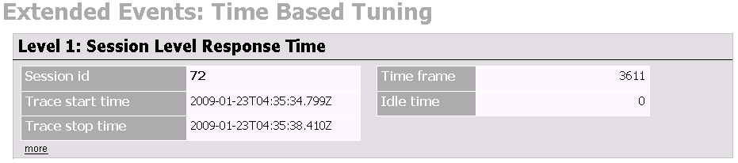

This will tell you which session was traced at what time the trace was started and stopped, and the total time spent tracing plus if there where time between executing statements. (Idle time.)

**Total response time for all statements**

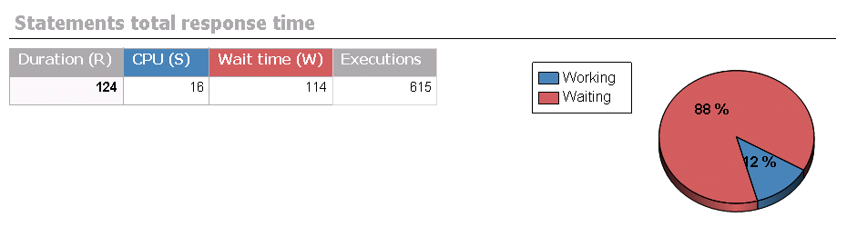

This view will give you the aggregated response time, plus service and wait time for all the statements captured in the trace.

From this view you can drill down to the session level wait time report by clicking on either the Wait Time column header or the chart. Or you can drill down to the session level service time report by clicking on either the Service Time column header or the chart.

This report also gives you a list of top 10 individual statements ordered by response time for the duration of the trace. You can also drill down to the statement level response time report, by clicking on a statement.

## Level 2 and Level 3 Reports

All reports have similar structure, and they provide information as indicated by the following table:

|  |  |  |
| --- | --- | --- |
| Level | Report Name | Information in the report |
| 2 | Session Level Service Time | Top 10 statements ordered by Service Time |
| 2 | Session Level Service Time | Session Top 5 Wait Events  Top 10 statements ordered by Wait Time |
| 2 | Statement Level Response Time | Statement Response Time Analysis  Logical Reads, Physical Reads  SQL Text |
| 3 | Statement Level Service Time | Statement Start Time, End Time |
| 3 | Statement Level Service Time | Statement Top 5 Wait Events |